**ASSIGNMENT – 4**

**ON: DATABASE CONSTRAINTS**

**Q1. Add a table-level PRIMAY KEY constraint to the EMP table on the ID column. The constraint should be named at creation. Name the constraint my_emp_id_pk. Hint: The constraint is enabled as soon as the ALTE TABLE command executes successfully.**

Ans1.

ALTER TABLE EMP

ADD CONSTRAINT my_emp_id_pk

PRIMARY KEY(ID);

**Q2. Create a PRIMARY KEY constraint to the DEPT table using the ID column. The constraint should be named at creation. Name the constraint my_deptid_pk. Hint: The constraint is enabled as soon as the ALTE TABLE command executes successfully.**

Ans2.

ALTER TABLE DEPT

ADD CONSTRAINT my_deptid_pk

PRIMARY KEY(ID);

**Q3. Add a column DEPT_ID to the EMP table. Add a foreign key reference on the EMP table that ensures that the employee is not assigned to a nonexistent department. Name the constraint my_emp_dept_id_fk.**

Ans3.

ALTER TABLE EMP

ADD (DEPT_ID NUMBER(8));

ALTER TABLE EMP

ADD CONSTRAINT my_emp_dept_id_fk

FOREIGN KEY (DEPT_ID)

REFERENCES EMP(ID);

**Q4. Confirm that the constraints were added by querying the USER_CONSTRAINTS view. Note the types and names of the constraints. Save your statement text in a file called lab4_4.sql.**

|  |  |
| --- | --- |
| **CONSTRAINT_NAME** | **C** |
| **MY_DEPTID_PK** | **P** |
| **MY_EMP_ID_PK** | **P** |
| **MY_EMP_DEPT_ID_FK** | **R** |

Ans4.

SELECT constraint_name, constraint_type

FROM user_constraints

WHERE table_name='EMP' OR table_name='DEPT';

**Verification table -**

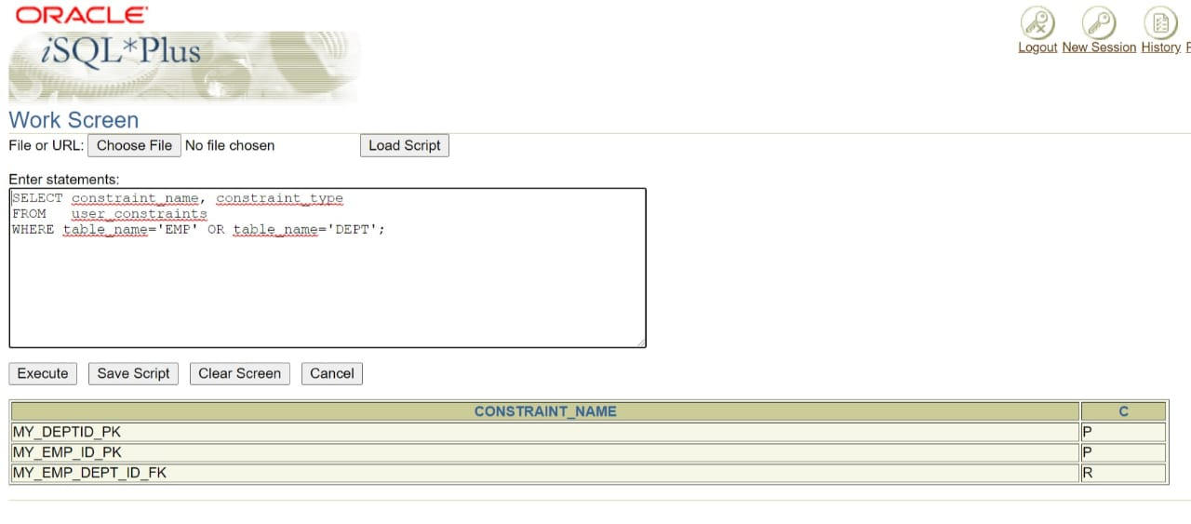

**Q5. Display the object names and types from the USER_OBJECTS data dictionary view for the EMP and DEPT tables. Notice that the new tables and a new index were created.**

Ans5.

SELECT object_name, object_type

FROM user_objects

WHERE object_name='EMP' OR object_name='DEPT';

**Verification table -**

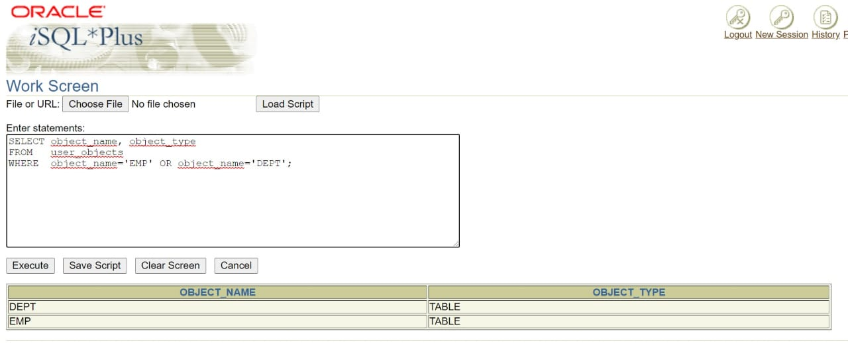

**If you have time, complete the following exercise.**

**Q6. Modify the EMP table. Add a COMMISSION column of NUMBER data type, precision 2, scale 2. Add a constraint to the commission column that ensures that a commission value is greater than zero.**

Ans6.

ALTER TABLE EMP

ADD COMMISSION NUMBER(2,2) CONSTRAINT emp_comm_min

CHECK (COMMISSION>0);